**Real world Use Case of NoSQL Databases**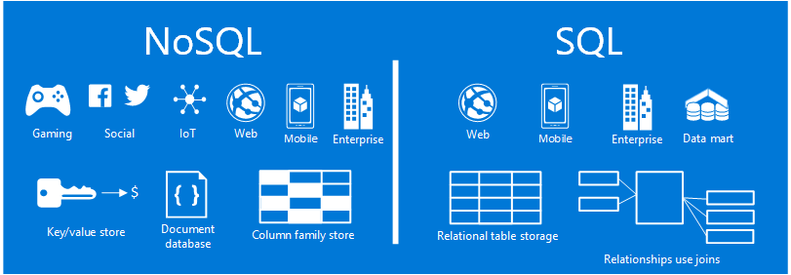

**1. Retail Sectors:**

Retailers like **Tesco** and media companies like **Sky leverage Couchbase** to manage vast amounts of semi-structured data. Tesco uses Couchbase for centralized catalog management, enabling seamless access to millions of product records across its operations. Sky, Europe's largest media company, relies on Couchbase to deliver high-demand content to over 22 million subscribers during peak times. Couchbase's JSON document model and real-time analytics capabilities allow these companies to provide personalized experiences and maintain high performance

**2. Banking Sectors:**

A leading private bank in India adopted Oracle NoSQL Database to modernize its digital presence and deliver a seamless customer experience. The bank faced challenges such as meeting real-time service-level agreements (e.g., processing loans in under 10 seconds), providing a unified customer 360° view, and ensuring high availability. Oracle NoSQL's flexible JSON document model allowed the bank to store structured and unstructured data efficiently, while its scale-out architecture ensured predictable scalability and disaster recovery. The bank also utilized Oracle NoSQL's integration with Elasticsearch for analytics and retargeting campaigns, enabling personalized customer interactions.

**3. Social Media Sectors:**

**Facebook & Netflix – Column-Family Store (Cassandra)** Handles massive datasets across multiple servers for social interactions, messaging, and analytics.

Benefit: Supports horizontal scalability with low latency, improving multi-dimensional query performance by over 20%.

**Snapchat & Twitter – Key-Value Store (Redis)** Manages session state and caching of frequently accessed data.

Benefit: Submillisecond latency with high throughput; performance scaled 2x faster while maintaining session consistency

**4. Education :**

**Learning Analytics:** NoSQL enables collection and analysis of real-time student interactions, clickstream data from learning management systems (LMS), and assessment results.

**Large-Scale Research Storage**: NoSQL databases allow storage and retrieval of heterogeneous research datasets, such as experimental logs, survey data, or genomic data, without rigid schemas.

**Data Analytics and MIS Courses:** Universities are increasingly incorporating NoSQL into coursework to teach students practical skills in contemporary data management.

**Dynamic Content Management:** Platforms hosting videos, quizzes, e-books, and interactive simulations leverage **document-oriented NoSQL systems** to manage heterogeneous content with evolving schemas without downtime.